Directions: Copy and paste into an email, adjusting the text for your audience as needed.

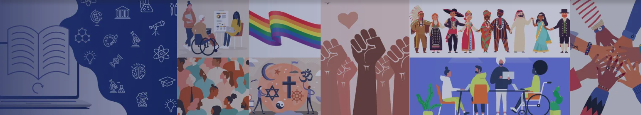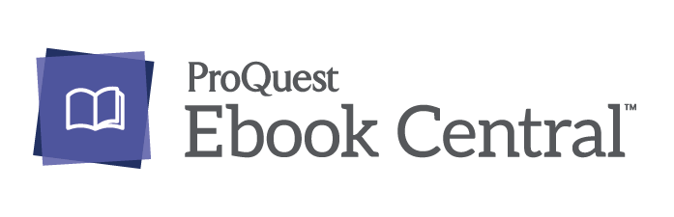

Dear [Faculty Member],

Faculty members across every discipline are in search of authoritative diverse content that aligns to their courses. To help support these needs, [library’s name] has subscribed to a brand new diverse ebook subscription that is now available to students and faculty!

Designed with students and educators in mind, the Diversity Equity and Inclusion Subscription has thousands of unlimited, multi-user ebooks representing every voice – regardless of gender, race, sexual orientation, physical ability and religious belief. It supports teaching, learning and research in the classroom and beyond.

This subscription is built with thousands of librarian-selected titles covering popular topics on diversity and inclusion like-

- Asian Studies
- Women's Studies
- Black Studies
- Hispanic/Latino Studies
- African Studies
- Jewish Studies
- Gender and Sexuality Studies
- Islamic Studies
- Poverty Studies
- Disability Studies
- Indigenous Studies
….And more!

With this new ebook subscription, faculty and students have access to:
- A critical mass of curated content. On-staff librarians are always adding new content to serve the changing needs of researchers - giving your students access to 18,000+ titles on important topics listed above.
- Tools that produce quality research, such as the ability to create personalized research bookshelves, bookmark important passages, take notes and generate citations.
- Unlimited, multi-user access that allows researchers to search, retrieve, save and access content at any time without user limits.
- User-centric tools for researchers to access titles or chapters shared by faculty through syllabi or an LMS.
Many faculty members have explored and added some interesting titles to their curriculum.

For access, go to [insert direct URL or institutional access instructions].

Please feel free to contact me with any questions regarding Ebook Central, or if you have suggestions for how we can help support you and your students via the library’s online resources.

Sincerely,

[Your name & contact information]

