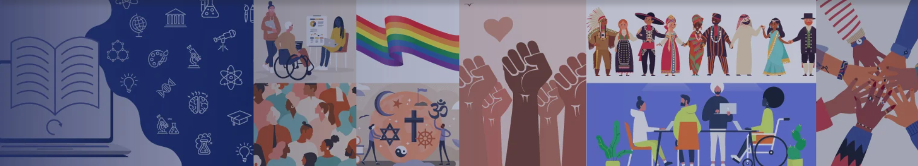
New to the Library: XYZ New DEI Ebooks from ProQuest
Library Collections News: Unlimited, Multi-user Access Ebooks on Diversity, Equity and Inclusion
The University [NAME] Library Team is pleased to share that the Library recently invested in thousands of new ebooks from ProQuest. Designed with students and educators in mind, the Diversity Equity and Inclusion Subscription has thousands of unlimited, multi-user ebooks representing every voice – regardless of gender, race, sexual orientation, physical ability and religious belief. It supports teaching, learning and research in the classroom and beyond.
This ebook collections is built with thousands of librarian-selected titles covering popular topics on diversity and inclusion like -

- Asian Studies
- Women's Studies
- Black Studies
- Hispanic/Latino Studies
- African Studies
- Jewish Studies
- Gender and Sexuality Studies
- Islamic Studies
- Poverty Studies
- Disability Studies
- Indigenous Studies

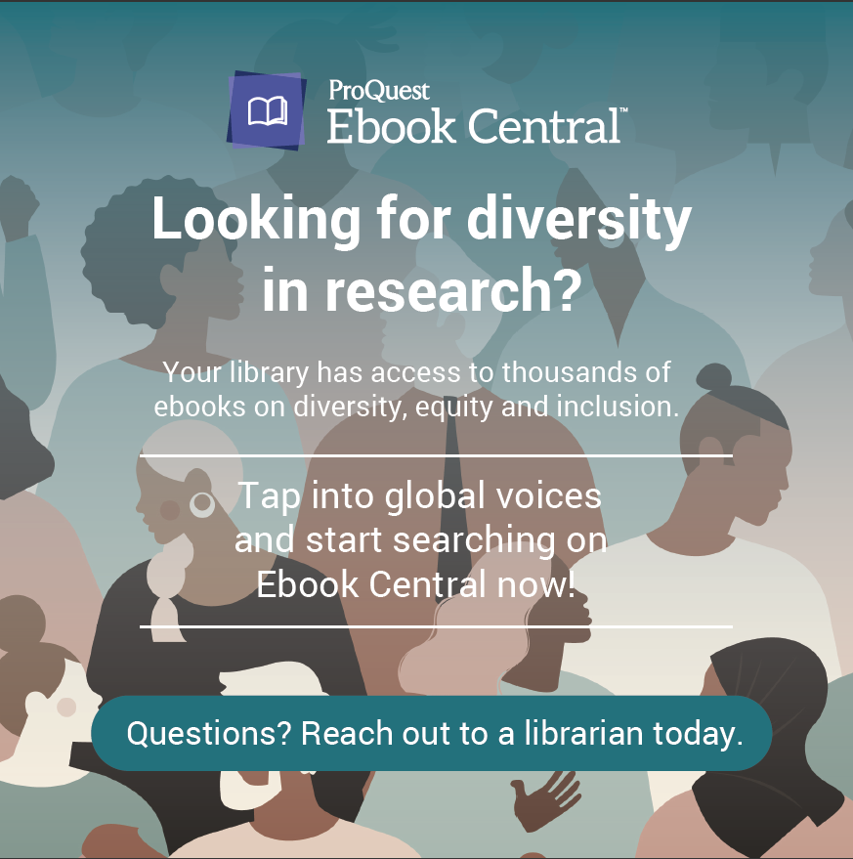

How to access?
Log-in via the university’s ProQuest accounts or speak to a member of the Library team for details.
Explore these unique ebooks and amplify your classroom discussions, curriculum and assignments.
Access is only available to current students and staff at University of [NAME].

